Thiol Disulfide Homeostasis
Thiols, also known as mercaptans, are a class of organic compounds that contain a sulfhydryl group (–SH) composed of a sulphur atom and a hydrogen atom attached to a carbon atom. The plasma thiol pool is mainly formed by albumin thiols, protein thiols and slightly formed by low-molecular-weight thiols such as cysteine (Cys), cysteinylglycine, glutathione, homocysteine and γ- glutamylcysteine.
Thiols (RSH) can undergo oxidation reaction via oxidants and form disulphide (RSSR) bonds. A disulphide bond is a covalent bond; the linkage is also called a SS-bond or disulphide bridge. Under conditions of oxidative stress, the oxidation of Cys residues can lead to the reversible formation of mixed disulphides between protein thiol groups and low-molecular-mass thiols. The formed disulphide bonds can again be reduced to thiol groups; thus, dynamic thiol–disulphide homeostasis is maintained.
Dynamic thiol disulphide homeostasis status has critical roles in antioxidant protection, detoxiﬁcation, signal transduction, apoptosis, regulation of enzymatic activity and transcription factors and cellular signalling mechanisms. Moreover, dynamic thiol disulphide homeostasis is being increasingly implicated in many disorders. There is also a growing body of evidence demonstrating that an abnormal thiol disulphide homeostasis state is involved in the pathogenesis of a variety of diseases, including diabetes [1-3], cardiovascular disease [4-10], cerebrovascular disase [11], malignacies [12], ankylosing spondylitis [13], preeclampsia [14,15], Alzheimer's disease [16], migraine [17], infections [18,19], and various disorders. Therefore, determination of dynamic thiol disulphide homeostasis can provide valuable information on various normal or abnormal biochemical processes. This easy, practical, fully automated and also optionally manual spectrophotometric assay can be used to determine plasma dynamic thiol/disulphide homeostasis.
Thiol Disulfide Homeostasis Tests
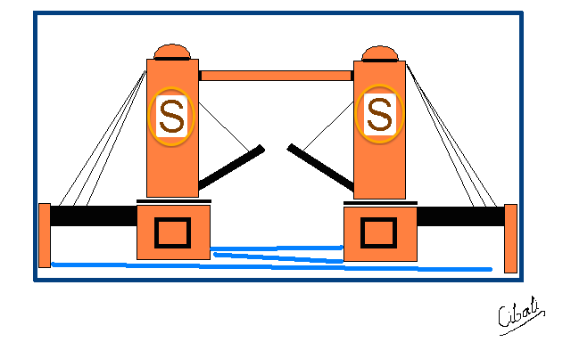 | 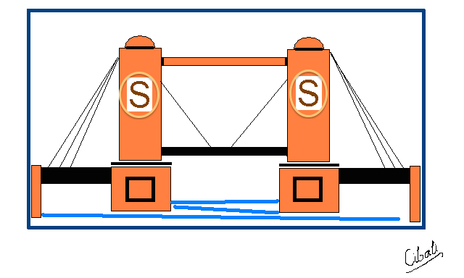
- Native Thiol Status (-SH) (Kit 100 test)
- Dynamic Disulfide Status (-S-S-) Hesaplama Parametresi
- Total (Oxidized and Reduced) Thiol Status (-SH + -S-S-) (Kit 100 test)
- Reduced Thiol Ratio [(-SH)/ (-SH + -S-S-)]X 100 Hesaplama parametresi
- Oxidized Thiol (disulfide) Ratio [(-S-S-)/ (-SH + -S-S-)] X 100 (Hesaplama Parametresi
- Thiol Oxidation Reduction Ratio [[(-SH)/ (-S-S-)]X 100 (Hesaplama parametresi

Priniciple of the Assay
Reducible disulphide bonds were reduced to form free functional thiol groups. Unused reductant sodium borohydride was consumed and removed with formaldehyde, and all thiol groups including reduced and native thiol groups were determined after the reaction with 5,5’-dithiobis-(2-nitrobenzoic) acid (DTNB). Half of the difference between the total thiols and the native thiols was recorded as the dynamic disulphide amount. After the native thiols (SH) and total thiols were determined, disulphide (SS) amounts, disulphide/total thiol percent ratios (SS/SH+SS), disulphide/native thiol percent ratios (SS/SH), and native thiol/total thiol percent ratios (SH/SH+SS) were calculated [20].
Application parameters of the assays
Sample volume: 10 μL
R1 volume (for total –SH): 10 μL
R1′ volume (for native –SH): 10 μL
R2 (2′) volume: 110 μL,
R3 (3′) volume: 10 μL.
Wavelength (main wavelength): 415 nm, secondary wavelength 700 nm, (optionally bichromatic).
Reading point: End-point, increasing measurement; the ﬁrst absorbance is taken before the mixing of R2 and R3 and the last absorbance is taken when the reaction trace draws a plateau (assay duration is about 10 min).
Calibration type: Linear
The disulphide parameter is a value which can be calculated automatically as half of the difference of the two measured values. The assays can also be performed by manually using spectrophotometers or multiwell readers. All volumes of the samples and reagents must be increased at the same ratio. Use of a second (side) wavelength is optional.

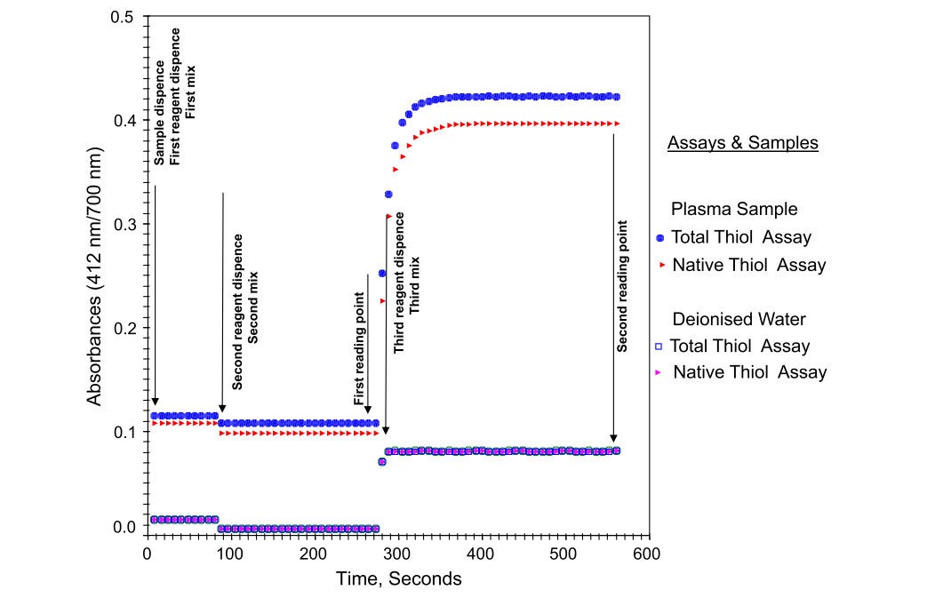
Figure. Reaction kinetics of the assays.
References
- Ates I, Kaplan M, Yuksel M, Mese D, Alisik M, Erel Ö, Yilmaz N, Guler S. Determination of thiol/disulphide homeostasis in type 1 diabetes mellitus and the factors associated with thiol oxidation. Endocrine. 2016 Jan;51(1):47-51. doi: 10.1007/s12020-015-0784-6. Epub 2015 Nov 7. PubMed PMID: 26547218.
- Ates I, Kaplan M, Inan B, Alisik M, Erel O, Yilmaz N, Guler S. How does thiol/disulfide homeostasis change in prediabetic patients? Diabetes Res Clin Pract. 2015 Nov;110(2):166-71. doi: 10.1016/j.diabres.2015.09.011. Epub 2015 Sep 24. PubMed PMID: 26421363.
- Ozler S, Oztas E, Caglar AT, Uygur D, Ergin M, Erel O, Danisman N. Thiol/disulfide homeostasis in predicting adverse perinatal outcomes at 24-28 weeks of pregnancy in gestational diabetes. J Matern Fetal Neonatal Med. 2016 Feb 24:1-6. [Epub ahead of print] PubMed PMID: 26769102.
- Kundi H, Ates I, Kiziltunc E, Cetin M, Cicekcioglu H, Neselioglu S, Erel O, Ornek E. A novel oxidative stress marker in acute myocardial infarction; thiol/disulphide homeostasis. Am J Emerg Med. 2015 Nov;33(11):1567-71. doi: 10.1016/j.ajem.2015.06.016. Epub 2015 Jun 14. PubMed PMID: 26143314.
- Kundi H, Erel Ö, Balun A, Çiçekçioğlu H, Cetin M, Kiziltunç E, Neşelioğlu S, Topçuoğlu C, Örnek E. Association of thiol/disulfide ratio with syntax score in patients with NSTEMI. Scand Cardiovasc J. 2015 Apr;49(2):95-100. doi: 10.3109/14017431.2015.1013153. Epub 2015 Mar 2. PubMed PMID: 25658436.
- Altiparmak IH, Erkus ME, Sezen H, Demirbag R, Kaya Z, Sezen Y, Gunebakmaz O, Asoglu R, Besli F, Neselioglu S, Erel O. Evaluation of thiol levels, thiol/disulfide homeostasis and their relation with inflammation in cardiac syndrome X. Coron Artery Dis. 2016 Jun;27(4):295-301. doi: 10.1097/MCA.0000000000000362. PubMed PMID: 26928883.
- Kundi H, Gok M, Cetin M, Kiziltunç E, Topcuoglu C, Neşelioğlu S, Erel O, Ulusoy FV. Association of thiol disulfide homeostasis with slow coronary flow. Scand Cardiovasc J. 2016 Mar 11:1-5. [Epub ahead of print] PubMed PMID: 26891417.
- Ateş İ, Ozkayar N, Altay M, Yilmaz FM, Topçuoğlu C, Alışık M, Erel Ö, Dede F. Is disulphide/thiol ratio related to blood pressure in masked hypertension? Clin Exp Hypertens. 2016;38(2):150-4. doi: 10.3109/10641963.2015.1060995. Epub 2015Sep 29. PubMed PMID: 26418425.
- Erkus ME, Altiparmak IH, Akyuz AR, Demirbag R, Sezen Y, Gunebakmaz O,Neselioglu S, Erel O. The association between plasma thiol levels and left ventricular diastolic dysfunction in patient with hypertension. Scand J Clin Lab Invest. 2015;75(8):667-73. Epub 2015 Aug 7. PubMed PMID: 26252832.
- Ates I, Ozkayar N, Inan B, Yilmaz FM, Topcuoglu C, Neselioglu S, Erel O, Dede F, Yilmaz N. Dynamic thiol/disulphide homeostasis in patients with newly diagnosed primary hypertension. J Am Soc Hypertens. 2016 Feb;10(2):159-66. doi: 10.1016/j.jash.2015.12.008. Epub 2015 Dec 15. PubMed PMID: 26725016.
- Bektas H, Vural G, Gumusyayla S, Deniz O, Alisik M, Erel O. Dynamic thiol-disulfide homeostasis in acute ischemic stroke patients. Acta Neurol Belg. 2016 Jan 18. [Epub ahead of print] PubMed PMID: 26782823.
- Guney T, Kanat IF, Alkan A, Alisik M, Akinci S, Silay K, Neselioglu S, Dilek I, Erel O. Assessment of serum thiol/disulfide homeostasis in multiple myeloma patients by a new method. Redox Rep. 2016 May 19:1-6. [Epub ahead of print] PubMed PMID: 27198712.
- Dogru A, Balkarli A, Cetin GY, Neselioglu S, Erel O, Tunc SE, Sahin M. Thiol/disulfide homeostasis in patients with ankylosing spondylitis. Bosn J Basic Med Sci. 2016 May 16. doi: 10.17305/bjbms.2016.1001. [Epub ahead of print] PubMed PMID: 27186972.
- Korkmaz V, Kurdoglu Z, Alisik M, Cetin O, Korkmaz H, Surer H, Erel O. Impairment of thiol-disulfide homeostasis in preeclampsia. J Matern Fetal Neonatal Med. 2016 Mar 3:1-6. [Epub ahead of print] PubMed PMID: 26828694.
- Ozler S, Erel O, Oztas E, Ersoy AO, Ergin M, Sucak A, Neselioglu S, Uygur D, Danisman N. Serum Thiol/Disulphide Homeostasis in Preeclampsia. Hypertens Pregnancy. 2015 Nov;34(4):474-485. Epub 2015 Nov 20. PubMed PMID: 26588703.
- Gumusyayla S, Vural G, Bektas H, Deniz O, Neselioglu S, Erel O. A novel oxidative stress marker in patients with Alzheimer's disease: dynamic thiol-disulphide homeostasis. Acta Neuropsychiatr. 2016 Apr 4:1-6. [Epub ahead of print] PubMed PMID: 27040443.
- Gumusyayla S, Vural G, Bektas H, Neselioglu S, Deniz O, Erel O. A novel oxidative stress marker in migraine patients: dynamic thiol-disulphide homeostasis. Neurol Sci. 2016 May 3. [Epub ahead of print] PubMed PMID: 27142446.
- Tufan ZK, Hasanoglu I, Kolgelier S, Alisik M, Ergin M, Yilmaz GR, Tasyaran MA, Erel O, Guner R. A retrospective controlled study of thiol disulfide homeostasis as a novel marker in Crimean Congo hemorrhagic fever. Redox Rep. 2016 May 9:1-5. [Epub ahead of print] PubMed PMID: 27159644.
- Kara SS, Erel O, Demirdag TB, Cura Yayla BC, Gulhan B, Neselioglu S, Polat M, Kalkan G, Tapisiz A, Tezer H. Alteration of thiol-disulphide homeostasis in acute tonsillopharyngitis. Redox Rep. 2016 Apr 20:1-5. [Epub ahead of print] PubMed PMID: 27096391.
- Erel O, Neselioglu S. A novel and automated assay for thiol/disulphide homeostasis. Clin Biochem. 2014 Dec;47(18):326-32. doi: 10.1016/j.clinbiochem.2014.09.026. Epub 2014 Oct 7. PubMed PMID: 25304913.

Tiyol Disülfid Homeostazı
Merkaptan olarak da bilinen tiyoller, bir kükürt atomundan ve bir karbon atomuna bağlı bir hidrojen atomundan oluşan bir sülfhidril grubu (-SH) içeren bir organik bileşikler sınıfıdır. Plazma tiyol havuzu temel olarak albümin tiyolleri, protein tiolleri ve hafif sistein (Cys), sisteinilglisin, glutatyon, homosistein ve glu-glutamilsistein gibi düşük moleküler ağırlıklı tiollerden oluşur.
Tiyoller (RSH) oksidanlar yoluyla oksidasyon reaksiyonuna girebilir ve disülfit (RSSR) bağları oluşturabilir. Bir disülfür bağı bir kovalent bağdır; bağlantı ayrıca bir SS-bağ veya disülfür köprüsü olarak da adlandırılır. Oksidatif stres koşulları altında, Cys kalıntılarının oksidasyonu, protein tiyol grupları ve düşük moleküler kütleli tiyoller arasında tersinir karışık disülfür oluşumuna yol açabilir. Oluşan disülfit bağları tekrar tiyol gruplarına indirgenebilir; Böylece, dinamik tiyol-disülfid homeostazı korunur.
Dinamik tiyol disülfit homeostazının durumu, antioksidan koruma, detoksifikasyon, sinyal iletimi, apoptoz, enzimatik aktivitenin düzenlenmesi ve transkripsiyon faktörleri ve hücresel sinyalleşme mekanizmalarında kritik rol oynar. Ayrıca, dinamik tiyol disülfit homeostazı, birçok rahatsızlığa giderek daha fazla dahil olmaktadır. Ayrıca, anormal bir tiyol disülfid homeostazı durumunun, diyabet [1-3], kardiyovasküler hastalık [4-10], serebrovasküler hastalık [11], maligniteler de dahil olmak üzere çeşitli hastalıkların patogenezinde rol oynadığını gösteren artan bir kanıt organı vardır. [12], ankilozan spondilit [13], preeklampsi [14,15], Alzheimer hastalığı [16], migren [17], enfeksiyonlar [18,19] ve çeşitli bozukluklar. Bu nedenle, dinamik tiyol disülfid homeostazının belirlenmesi, çeşitli normal veya anormal biyokimyasal işlemler hakkında değerli bilgiler sağlayabilir. Bu kolay, pratik, tamamen otomatik ve ayrıca isteğe bağlı olarak manuel spektrofotometrik analiz, plazma dinamik tiyol / disülfit homeostazını belirlemek için kullanılabilir.

Testin Prensibi
İndirgenebilir disülfit bağları serbest fonksiyonel tiyol grupları oluşturmak için azaltıldı. Kullanılmayan indirgeyici sodyum borohidrid tüketildi ve formaldehit ile çıkarıldı ve indirgenmiş ve doğal tiyol grupları dahil olmak üzere tüm tiyol grupları, 5,5-ditiobis- (2-nitrobenzoik) asit (DTNB) ile reaksiyondan sonra belirlendi. Toplam tiyoller ve doğal tiyoller arasındaki farkın yarısı, dinamik disülfür miktarı olarak kaydedildi. Doğal tiyoller (SH) ve toplam tiyoller belirlendikten sonra, disülfür (SS) miktarları, disülfid / toplam tiyol yüzde oranları (SS / SH + SS), disülfid / doğal tiyol yüzde oranları (SS / SH) ve doğal tiyol / toplam yüzde tiyol oranları (SH / SH + SS) hesaplandı [20].

